**Project Report 7**

**NAME: DHIVAKAR.R**

**COURSE: AI and ML**

Project Based On Spherical K-Means: Pattern Discovery in Textures

Question:

Generate a dummy dataset using Scikit-Learn having high dimensionality (number of features >10) and total 4 classes. For this dataset, first implement K-Means clustering and then use the clusters for classification purpose. Now using the same dataset, implement spherical clustering and then check accuracy for classification. Notice the change in accuracy. You may also plot the obtained clusters from both the methods using t-SNE plots or by projecting data into two dimensions using PCA.

**Prerequisites**

What things you need to install the software and how to install them:

Python 3.6 This setup requires that your machine has latest version of python. The following url <https://www.python.org/downloads/> can be referred to download python. Once you have python downloaded and installed, you will need to setup PATH variables (if you want to run python program directly, detail instructions are below in how to run software section). To do that check this: <https://www.pythoncentral.io/add-python-to-path-python-is-not-recognized-asan-internal-or-externalcommand/> . Setting up PATH variable is optional as you can also run program without it and more instruction are given below on this topic.

Second and easier option is to download anaconda and use its anaconda prompt to run the commands. To install anaconda check this url <https://www.anaconda.com/download/> You will also need to download and install below 3 packages after you install either python or anaconda from the steps above Sklearn (scikit-learn) numpy scipy if you have chosen to install python 3.6

**Importing library and dataset:**

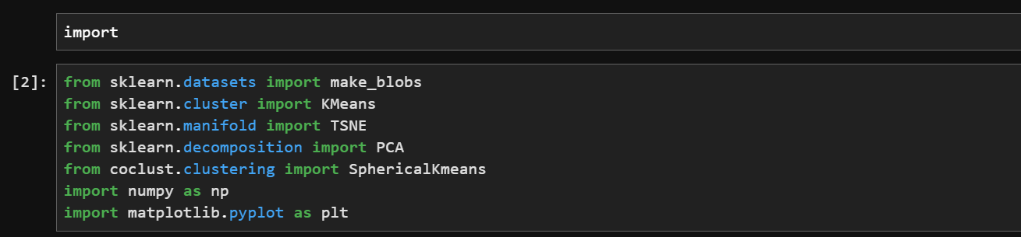

**Dataset**

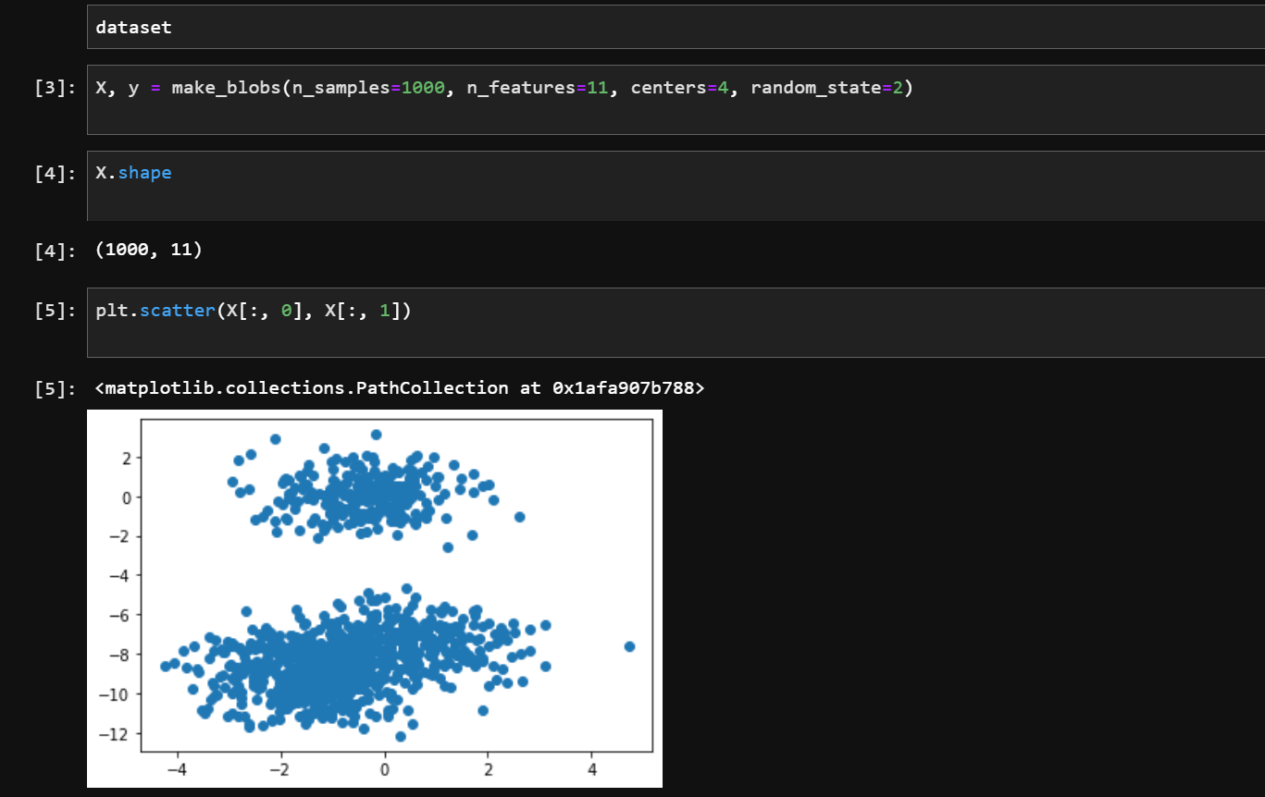

**K-Means**

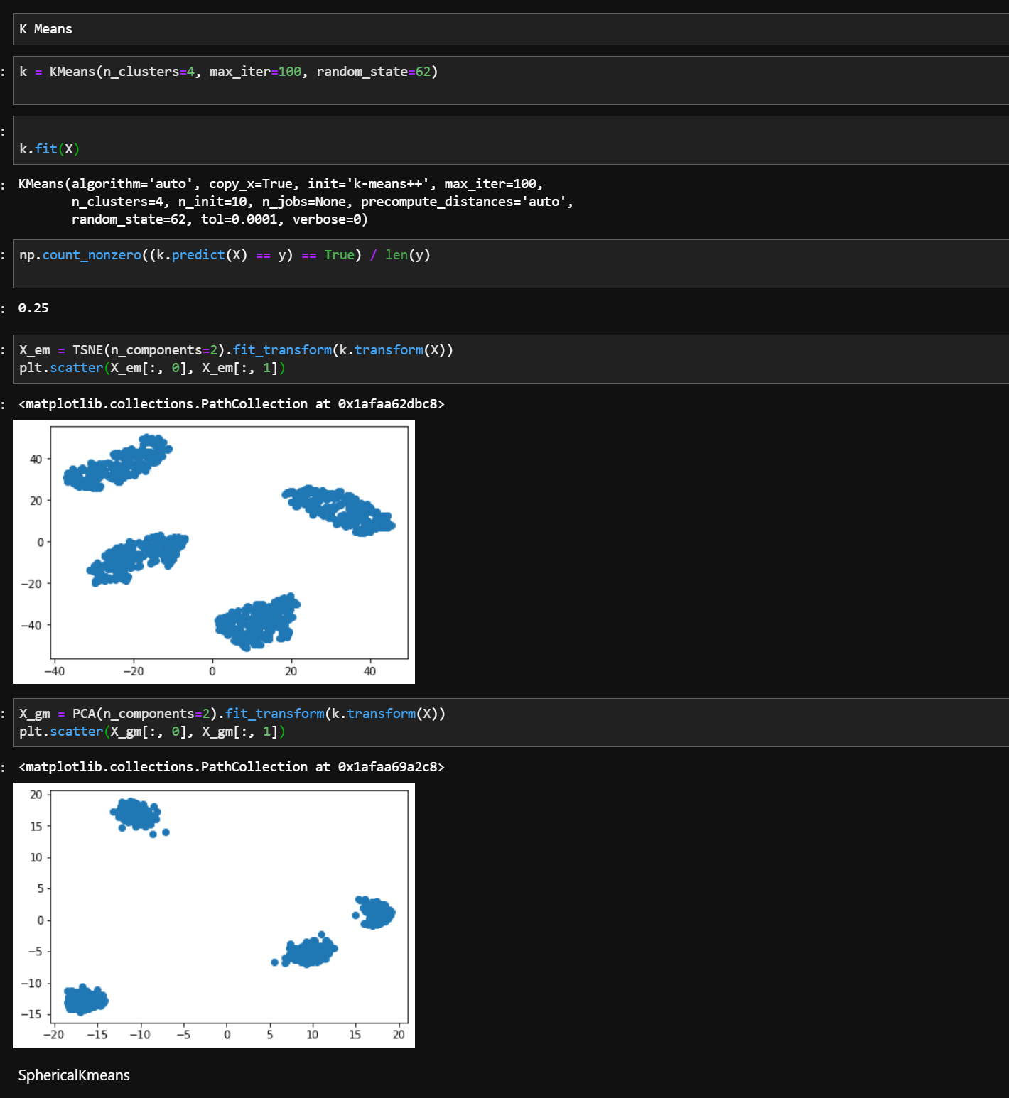

**Spherical Kmeans**

